THE 2004 INTERNATIONAL PARLIAMENTARIANS’ CONFERENCE ON THE IMPLEMENTATION OF THE ICPD PROGRAMME OF ACTION
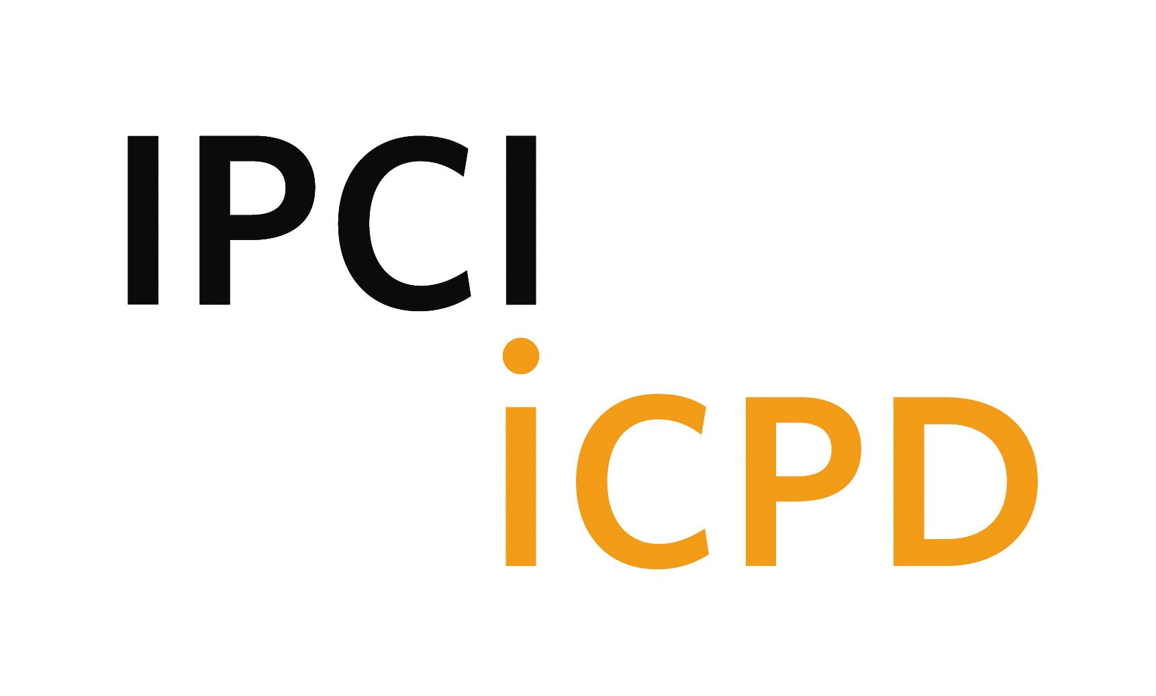

AGENDA

Sunday, 17th October

10:00-22:00 Registration (Lobby of Hilton Strasbourg and Holiday Inn Strasbourg City
Centre)

15:00-16:00 Briefing For Resource Persons and Rapporteurs of the Group
Discussions (Hilton Strasbourg, B1, Neptune)

17:00-18:00 Drafting committee meeting (Hilton Strasbourg, B1, Neptune)

18:00-20:00 Welcome Reception offered by the French National Assembly
Delegation on Women’s Rights and Equal Opportunities between Men
and Women
Ms. Marie-Jo Zimmermann, MP, President of Delegation
(Hilton Strasbourg, Ground Fl., Churchill)

20:00-22:00 Steering Committee Meeting (Hilton Strasbourg, B1, Neptune)

Monday, 18th October

8:00-12:00 Registration (continued) (Council of Europe, lobby area; lobby of Hilton
Strasbourg and Holiday Inn Strasbourg City Centre)

9:00-10:00 Opening Ceremony (Council of Europe, Hemicycle)
MC: Chair, Steering Committee

1. Purpose of the Conference
Ms. Safiye Çağar, Director, Information, Executive Board and Resource
Mobilization Division, United Nations Population Fund (UNFPA)
2. Video Presentation
3. Opening Remarks
- H.E., the Rt. Hon. Terry Davis, Secretary General, Council of Europe
- H.E. Mr. Marcel Glesener, Vice-President, Parliamentary Assembly of the
Council of Europe
- H.E. Mr. Xavier Darcos, Deputy Minister for International Development,
France

4. Keynote Speech
- Ms. Thoraya A. Obaid, Executive Director, UNFPA
- Dr. Steven W. Sinding, Director-General, International Planned Parenthood
Federation (IPPF)

10:00-10:30 Opening Session (Council of Europe, Hemicycle)
- Election of Officers
Chair, Steering Committee
2. Election of Drafting Committee Members
Chair of the Conference

10:30-10:50 Coffee Break (Council of Europe, outside Hemicycle)

10:50-12:30 Session 1 (Council of Europe, Hemicycle)
Special Guest Statements: 10 Years After Cairo – Successes and Constraints
Moderator: Ms. Imelda J. Henkin, Deputy Executive Director (Management)

Speakers (7-10 minute presentations and Q & A):
- H.E. Dr. Nilcea Freire, Minister for Women’s Affairs, Brazil
- H.E. Dr. Mohamed Awad Tag El Dine, Minister for Health and Population,
Egypt
- H.E. Ms. Charity K. Ngilu, Minister for Health, Kenya
- H.E. Ms. Agnes van Ardenne, Minister for Development Cooperation, The
Netherlands
- H.E. Mr. Gareth Thomas, Parliamentary Under-Secretary of State for
International Development, U.K.
- H.E. Ms Annika Söder, State Secretary for Development Co-operation,
Sweden

12:30-12:45 Reproductive Health Commodity Security: Launch of Brochure
“Securing the Supplies that People Rely On” (Council of Europe, Hemicycle)
- H.E. Ms. Agnes van Ardenne, Minister for Development Cooperation, The
Netherlands
- H.E. Ms. Charity K. Ngilu, Minister for Health, Kenya
- Ms. Thoraya A. Obaid, Executive Director, UNFPA
- Dr. Steven W. Sinding, Director-General, IPPF

12:45-13:00 Group Photo (Council of Europe, outside Hemicycle)

13:00-14:30 Lunch (Council of Europe, Blue Restaurant)

14:30-16:00 Session 2 (Council of Europe, Hemicycle)
Panel Discussion: Progress in Resource Mobilization and Creating an Enabling Environment
Moderator: Dr. Nina Puri, President, IPPF

Panelists (7-10 minute presentations and Q & A):
- Ms. Elizabeth Lule, Advisor for Population and Reproductive Health, Nutrition and Population, Human Development Network, World Bank
- Dr. Lieve Fransen, Head of the Human and Social Development Unit, Directorate-General for Development, the European Commission
- Mr. Lester Brown, President, Earth Policy Institute
- Mr. Tony Worthington, MP, U.K.
- Dr. Reed Boland, Harvard University School of Public Health
- Ms. Christine McCafferty, MP, U.K.; Member, Parliamentary Assembly of the Council of Europe

16:00-16:20 Coffee Break (Council of Europe, in front of Committee Rooms)

16:20-17:50 Session 3 (Council of Europe, Committee Rooms)
Group Discussions – approx. 30-40 parliamentarians in each group

1. HIV/AIDS (Room 6)
Resource Person: Dr. Carol Jacobs, Director, National HIV/AIDS Commission, Barbados
2. Reproductive Health Commodity Security (Room 7)
Resource Person: Mr. Jagdish Upadhyay, Coordinator, Commodity Management Unit, Technical Support Division, UNFPA
3. Millennium Development Goals, Population and Reproductive Health (Room 10)
Resource Person: Mr. Stan Bernstein, Senior Sexual and Reproductive Health Policy Advisor, Millennium Project, UN Development Group
4. Adolescent Reproductive Health (Room 11)
Resource Person: Dr. Dina Krauskopf, Professor Emeritus, University of Costa Rica

17:50-18:00 Closing Of Day 1 (Council of Europe, Hemicycle)
Chair of the Conference

18:30-20:30 Welcome Reception offered by Mr. John Wilkinson, Chairperson of the
Committee on Migration, Refugees and Demography
On behalf of the President of the Parliamentary Assembly of the Council of Europe
(Council of Europe Blue Restaurant)

21:00-23:00 Drafting Committee Meeting (Hilton Strasbourg, B1, Neptune)

Tuesday, 19th October

8:00-8:45 Drafting Committee Meeting (Hilton Strasbourg, B1, Neptune)

9:00-10:30 Session 4 (Council of Europe, Committee Rooms)
Group Discussions – approx. 30-40 parliamentarians in each group

1. Reproductive Health in Emergency Situations (Room 6)
Resource Person: Ms. Pamela Delargy, Chief, Humanitarian Response Unit, UNFPA
2. Food, Water, Population and Environment (Room 7)
Resource Person: Mr. Lester Brown, President, Earth Policy Institute
3. Gender and Women’s Empowerment (Room 10)
Resource Person: Ms. Fama Hane Ba, Director, Africa Division, UNFPA
4. Maternal Mortality and Morbidity (Room 11)
Resource Person: Dr. Christiane Welffens-Ekra, President, Society for African Gynecologists and Obstetricians (SAGO)
10:30-10:50 Coffee Break (Council of Europe, outside Hemicycle)

10:50-12:00 Presentation of the Outcome of Discussion by Each Group (Council of Europe, Hemicycle)
MC: Chair of the Conference
Presentations by Chairs of the Group Discussions

12:00-14:00 Lunch (Council of Europe, Blue Restaurant)

14:00-15:00 Session 5 (Council of Europe, Hemicycle)
Discussion on the Draft Statement of Commitment
MC: Chair of the Conference
Introduction of the Draft Statement by: Chair, Drafting Committee

15:00-15:20 Coffee Break (Council of Europe, outside Hemicycle)

15:20-15:35 Session 6 (Council of Europe, Hemicycle)
Discussion on Follow-up
- Ms. Safiye Çağar, Director, Information, Executive Board and Resource
Mobilization Division, United Nations Population Fund (UNFPA)
- Mr. Neil Datta, Secretary, Inter-European Parliamentary Forum on Population
and Development (IEPFPD)

15:35-15:50 Closing Session (Council of Europe, Hemicycle)
1. Adoption of the Statement of Commitment
Chair of the Conference
2. Closing Remarks
Chair, Steering Committee

16:30 Tour of the City of Strasbourg (Departure through Blue Restaurant)

18:30-20:30 Reception hosted by Mayor of Strasbourg (Mairie de Strasbourg)

