THE 2006 INTERNATIONAL PARLIAMENTARIANS’ CONFERENCE ON THE IMPLEMENTATION OF THE ICPD PROGRAMME OF ACTION
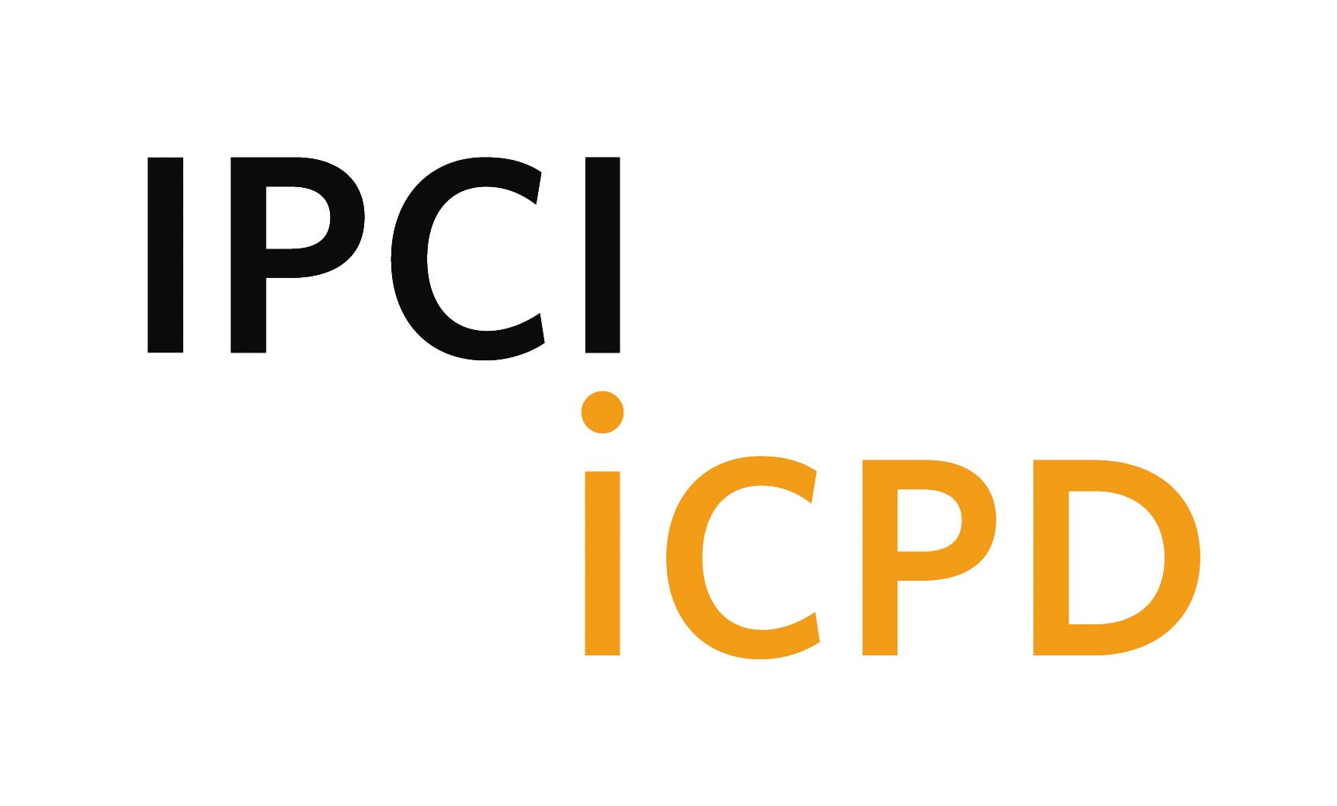

PROVISIONAL AGENDA

Monday, 20th November

10:00-22:00 Registration
(Siam City Hotel, Royal Princess Hotel and Prince Palace Hotel)

15:00-17:00 Steering Committee Meeting (Siam City Hotel)

17:30-18:30 Briefing For Chairs, Resource Persons and Rapporteurs of the Group
Discussions (Siam City Hotel)

19:30-21:00 Welcome Reception Hosted by President of National Legislative
Assembly of Thailand (Shangri-la Hotel)
- Mr. Meechai Ruchupan, President, National Legislative Assembly, Thailand

Launch of UNESCAP Asia-Pacific Population Journal (20th anniversary commemorative issue)

- Mr. Kim Hak-Su, Executive Secretary, UNESCAP
- Ms. Thoraya A. Obaid, Executive Director, UNFPA

21:00-22:00 Drafting committee meeting (Siam City Hotel)

Tuesday, 21ST November

9:00-10:00 Opening Ceremony (ESCAP Hall)

- Welcome Remarks
  - Mr. Yasuo Fukuda, MP (Japan) and Chair of AFPPD
- Ms. Thoraya A. Obaid, Executive Director, UNFPA
- Mr. Meechai Ruchupan, President, National Legislative Assembly, Thailand
2. Opening Remarks
- Her Royal Highness Princess Maha Chakri Sirindhorn

10:00-11:00 Opening Session (ESCAP Hall)
MC: Mr. Yasuo Fukuda, MP (Japan) and Chair of AFPPD
1. Purpose of the Conference
Ms. Safiye Çağar, Director, Information, Executive Board and Resource
Mobilization Division, UNFPA
2. Video Presentation
- Keynote Speech
- Mr. Kim Hak-Su, Executive Secretary, UNESCAP
- Ms. Thoraya A. Obaid, Executive Director, UNFPA
- Ms. Gill Greer, Director-General, IPPF
- Election of Officers
5. Election of Drafting Committee Members

11:00-11:20 Coffee Break (Outside ESCAP Hall)

11:20-12:50 Session 1 (ESCAP Hall)
Special Guest Statements: Taking Stock of Progress since Cairo – Role of Parliamentarians in Implementing the Cairo Agenda

Moderator: Mr. Alain Destexhe, Senator (Belgium) and President of PGA

Speakers (7-minute presentations by a minister from each region and Q & A):
- Mr. Zhang Weiqing, Minister, National Population and Family Planning
Commission, China
- Ms. Alicia Muñoz Alá, Minister of Governance, Bolivia
- Ms. Naziha Echik, Deputy Minister of Public Health and State Secretary, Tunisia
- Mr. Nassour Guelengdouksia Ouaïdou, President of the National Assembly, Chad

12:50-13:00 Group Photo (Reception Hall, Ground Floor)

13:00-14:30 Welcome Lunch Hosted by Thai Minister of Public Health
(Dining Room, 1st Floor)
- Dr. Mongkol Na Songkhla, Minister of Public Health, Thailand

14:30-16:30 Session 2
Group Discussions (per region)
Review Results of the Global Survey on Progress Made since Cairo and Recommend Future Strategies for National and Regional-Level Action
Asia and the Pacific (ESCAP Hall)
Africa (Conference room 1)
Inter-America (Conference room 2)
Arab States (Conference room 3)
Inter-Europe (Conference room 4)
Chairs: A parliamentarian from each region
Resource Persons: Secretariat of AFPPD, FAAPPD, IAPG and EPF

16:30-16:50 Coffee Break (Outside ESCAP Hall)

16:50-17:50 Session 3 (ESCAP Hall)
Presentation of the Outcome of Discussion by Each Group
Moderator: Dr. Malinee Sukavejworakit, Secretary General of AFPPD
Presentations by Chairs of the Group Discussions

17:50-18:00 Closing Of Day 1 (ESCAP Hall)

18:30-20:30 Reception to Celebrate 25th Anniversary of AFPPD
(Reception Hall, Ground Floor)

21:00-22:00 Drafting Committee Meeting (Siam City Hotel)

Wednesday, 22nd November

8:00-8:45 Drafting Committee Meeting (Meeting Room E, 1st floor, ESCAP)

9:00-10:40 Session 4
Group Discussions – approx. 30 parliamentarians in each group

1. Resource Mobilization: Financing the ICPD Agenda and the MDGs
Chair: A parliamentarian (T.b.d.) (Conference room 1)
Resource Person: Dr. Joe Speidel, Adjunct Professor, Department of Obstetrics, Gynecology and Reproductive Sciences, University of California San Francisco
2. National Strategies to Achieve Universal Access to Reproductive Health
Chair: A parliamentarian (T.b.d.) (Conference room 2)
Resource Person: Mr. Stan Bernstein, Senior Policy Advisor, Technical Support Division, UNFPA
3. Role of Parliamentarians in Implementing the ICPD Agenda and the MDGs
Chair: A parliamentarian (T.b.d.) (Conference room 3)
Resource Person: Mr. Sultan Aziz, Director, Asia and the Pacific Division, UNFPA
4. Countering challenges to the ICPD agenda
Chair : A parliamentarian (T.b.d.) (Conference room 4)
Resource Person: Mr. Jon O’Brien, Executive Vice-President, Catholics for a Free Choice
5. The Population-Environment Nexus and the MDGs
Chair : A parliamentarian (T.b.d.) (ESCAP hall)
Resource Person: Mr. Lester Brown, President, Earth Policy Institute

10:40-11:00 Coffee Break (Outside ESCAP Hall)

11:00-12:00 Session 5 (ESCAP Hall)
Presentation of the Outcome of Discussion by Each Group
Moderator: Ms. Thelma Kay, Director, Emerging Social Issues Division, UNESCAP Presentations by Chairs of the Group Discussions

12:00-13:00 Session 6 (ESCAP Hall)
Discussion on the Draft Statement of Commitment
Moderator: Dr. Mary Henry, Senator (Ireland) and Vice-President of EPF
Introduction of the Draft Statement by Chair of Drafting Committee

13:00-14:30 Lunch Hosted by Founding Member of AFPPD
(Dining Room, 1st Floor)
  - Prof. Dr. Prasop Ratanakorn, Honorary Founding Member and Former Secretary General of AFPPD

14:30-15:30 Session 7 (ESCAP Hall)
Discussion on the Draft Statement of Commitment (continued)
Moderator: Dr. Mary Henry, Senator (Ireland) and Vice-President of EPF

15:30-16:00 Session 8 (ESCAP Hall)
Discussion on Follow-up
- Ms. Safiye Cagar, Director, IERD, UNFPA
- Mr. Shiv Khare, Executive Director, AFPPD
- Host parliamentary group for the 2008 IPCI/ICPD:
Ms. Khira Lagha, MP (Tunisia) and Chair of FAAPPD

16:00-16:30 Closing Session (ESCAP Hall)
1. Adoption of the Statement of Commitment
2. Closing Remarks
Chair of the Conference

